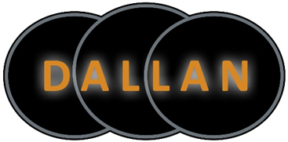

Dallan LP is a partnership between Lac Des Milles Lac First Nation, Nigigoonsiminikaaning First Nation and Dale Levesque, a member of the Fort William First Nation. Dallan LP is a 100% aboriginal owned business that provides industrial yard services which includes a variety of heavy equipment operations, maintenance and general labour. Dallan LP currently has four separate contracts/ operations in Northwestern Ontario. Dallan LP is committed to the needs of its customers while ensuring the Health & Safety of all its employees.

POSITION – EQUIPMENT OPERATORS
LOCATION – THUNDER BAY, ON
SALARY – $23.06 - $27.13

Equipment Operators will operate a variety of equipment at the work sites. Duties are, but not limited to; log unloading and loading, lumber transfer, kiln loading, finished lumber loading, snow removal. Equipment operators will be expected to operate all equipment smoothly, efficiently and in a safe manner.

Qualifications:
- Valid ‘G’ Driver’s License
- Previous experience operating heavy equipment
- Able to work shift work (days, nights, weekends)
- Physically capable of working 40-48 hours per week on heavy equipment
- Highly motivated and committed to Health and Safety

Dallan offers competitive wages, a full benefit plan and a defined contribution pension plan. A portion of the work force in on first nation land therefore there is the opportunity for tax exempt pay for employees with First Nation status.

If interested: Please apply, in confidence by email, to recruitment@dallanforestry.ca

